28.6: a) 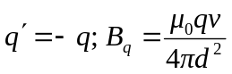 into the page; 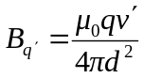 out of the page.
(i) 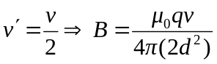 into the page.
(ii) 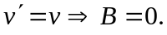
(iii) 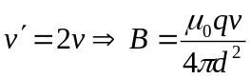 out of the page.
b) 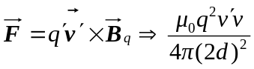 and is attractive.
c) 